|  |  |
| --- | --- |
| *Pacific Gas and Electric Company* | |
| Release 7.7.2 Installation Guide | |
|  |  |
|  |  |
| Project | ED AM/GIS |
|  |  |
| Prepared by | Ashish Narasimham |
| Date | 5/9/2014 |
| Version | 1.0 |
| Version Type | Final |

|  |  |  |  |
| --- | --- | --- | --- |
| Revision History | | | |
| Document # | Date | Author | Summary of Changes |
| 1.0 |  | Ashish Narasimham | Initial Document Creation |

# Introduction

## Purpose

This document is intended to detail the implementation and configuration steps required to implement Release 7.7.2 Installation Guide. This document describes the various configuration aspects required to complete any manual or automatic patch associated with this release. Each section in this document contains the steps required to patch the system in production.

## Terms Used

|  |  |
| --- | --- |
| OOTB | Out of the box. Unmodified from the commercial version. |
| TFS | Team Foundation Server |

## External Documents

Referenced are any external configuration documents or exports. These are documents that contain more detailed information about configuring a system or documents that can be loaded into an application to perform the configuration detailed in this document.

1. Release Folder
   1. \\sfetgis-nas01\sfgispoc_data\ApplicationDevelopment\IBM_Delivery\EDER 2.1
2. ArcFM Properties XML
   1. \\sfetgis-nas01\sfgispoc_data\ApplicationDevelopment\IBM_Delivery\EDER 2.1
   2. File name: ArcFMProperties_TFS14408_EDGIS1Q.xml

## List Of Fixes

Below is the list of change requests detailing all fixes for the data model for this release:

|  |  |  |  |
| --- | --- | --- | --- |
| **Item Number** | | **Title** | **Work Item Type** |
| [14182](http://edappgistfsprd1:8080/tfs/web/wi.aspx?pcguid=15e9a9d1-95cb-4dd0-abfe-5af14ae6201f&id=14182) | | Master for Release 2.1 (Build 66) | Change Request |
| [13342](http://edappgistfsprd1:8080/tfs/web/wi.aspx?pcguid=15e9a9d1-95cb-4dd0-abfe-5af14ae6201f&id=13342) | Create new class model name PGE_PHASEVALIDATIONFORUNIT and PGE_UNIT and assign them to listed feature classes and tables | Change Request |
| [14183](http://edappgistfsprd1:8080/tfs/web/wi.aspx?pcguid=15e9a9d1-95cb-4dd0-abfe-5af14ae6201f&id=14183) | Change orientation of AUs in Transformer | Change Request |
| [14375](http://edappgistfsprd1:8080/tfs/web/wi.aspx?pcguid=15e9a9d1-95cb-4dd0-abfe-5af14ae6201f&id=14375) | Remove 'Admin (NO QA/QC) Post Session' from Process Framework (plus 'Test' tasks mentioned in details) --Install on Pre-Prod | Change Request |
| [14389](http://edappgistfsprd1:8080/tfs/web/wi.aspx?pcguid=15e9a9d1-95cb-4dd0-abfe-5af14ae6201f&id=14389) | EDER Snapping and Stored display on EDGIS1Q | Change Request |
| [14391](http://edappgistfsprd1:8080/tfs/web/wi.aspx?pcguid=15e9a9d1-95cb-4dd0-abfe-5af14ae6201f&id=14391) | Linear Features Change On Update For Anno | Change Request |
| [14395](http://edappgistfsprd1:8080/tfs/web/wi.aspx?pcguid=15e9a9d1-95cb-4dd0-abfe-5af14ae6201f&id=14395) | Remove the Job Year AU from All Feature Classes It Is Assigned To In The ElectricDataset On Feature Update | Change Request |
|  |  |  |
|  |  |  |
|  |  |  |

## Summary of Steps to Complete Patch

These are the high-level steps to complete the installation and configuration of the data model patch. Use this table as a guide for completing the installation. Links are provided that can lead either within the document for detailed explanations or to external sites such as Sharepoint.

Contents

1 Introduction 3

1.1 Purpose 3

1.2 Terms Used 3

1.3 External Documents 3

1.4 List Of Fixes 4

1.5 Summary of Steps to Complete Patch 4

2 Open a Database Connection in ArcCatalog 6

3 13342 - Create new class model name PGE_PHASEVALIDATIONFORUNIT and PGE_UNIT and assign them to listed feature classes and tables 7

4 ~~14183 - Change orientation of AUs in Transformer~~ 10

5 14391 - Linear Features Change On Update For Anno 11

6 ~~14395 - Remove the Job Year AU from All Feature Classes It Is Assigned To In The ElectricDataset On Feature Update~~ 12

7 14375 - Remove 'Admin (NO QA/QC) Post Session' from Process Framework (plus 'Test' tasks mentioned in details) 14

8 14389 - EDER Snapping and Stored display 15

9 Import ArcFM Properties XML 20

10 Update Data Model Version Table 21

11 Known Issues 22

# Open a Database Connection in ArcCatalog

1. Open ArcCatalog.
2. Within the Catalog Tree, expand “Database Connections” and open the active connection for this process. This is the connection that is referenced in the change request associated with this document (EDGIS<DB name in the format X#Y> )

# 13342 - Create new class model name PGE_PHASEVALIDATIONFORUNIT and PGE_UNIT and assign them to listed feature classes and tables

1. Create new class model name -- PGE_PHASEVALIDATIONFORUNIT under "PGE ED Object Class Model Name".
   1. Right click on the target database’s SDE file in ArcCatalog and select Properties.
   2. Select the Domains tab and scroll to the PGE ED Object Class Model Name domain.
   3. Scroll to the bottom of the list of codes/values in the bottom half of the screen and add PGE_PHASEVALIDATIONFORUNIT / PGE_PHASEVALIDATIONFORUNIT to the end of the list.  
      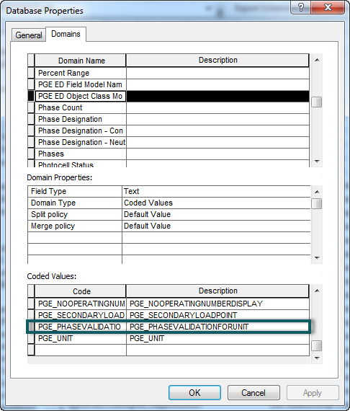
2. Create new class model name -- PGE_UNIT under "PGE ED Object Class Model Name".
   1. Right click on the target database’s SDE file in ArcCatalog and select Properties.
   2. Select the Domains tab and scroll to the PGE ED Object Class Model Name domain.
   3. Scroll to the bottom of the list of codes/values in the bottom half of the screen and add PGE_UNIT/PGE_UNIT to the end of the list.  
      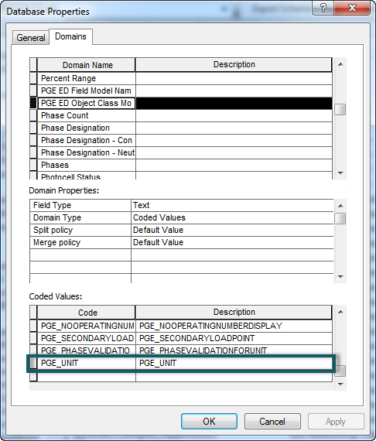
3. Assign PGE_PHASEVALIDATIONFORUNIT class model name to StepDown, Transformer and VoltageRegulator feature classes.
   1. In the ElectricDataset, right click the feature class and select ArcFM Properties Manager.
   2. Select the Model Names tab.
   3. Ensure the PGE ED Object Class Model Name entry is selected in the Model Name Domain dropdown.
   4. Double click PGE_PHASEVALIDATIONFORUNIT on the left hand side to assign it on the right side.
   5. Repeat the above steps for all feature classes.
4. Assign PGE_UNIT class model name to StepDownUnit, TransformerUnit and VoltageRegulatorUnit table.
   1. In the ElectricDataset, right click the table and select ArcFM Properties Manager.
   2. Select the Model Names tab.
   3. Ensure the PGE ED Object Class Model Name entry is selected in the Model Name Domain dropdown.
   4. Double click PGE_UNIT on the left hand side to assign it on the right side.
   5. Repeat the above steps for all tables.
5. Assign "PGE Validate Phase Designation" Validation rule to StepDown, Transformer and VoltageRegulator feature classes.
   1. In the ElectricDataset, right click the feature class and select ArcFM Properties Manager.
   2. Select the Object Info tab.
   3. In the bottom half of the screen, scroll down until you see the rule PGE Validate Phase Designation and click the checkbox next to it to turn it on.
   4. Repeat the above steps for all feature classes.

# ~~14183 - Change orientation of AUs in Transformer~~

1. ~~In ArcCatalog, Open ArcFM Properties manager for "Transformer".~~
2. ~~In Object Info Tab, for "On Feature Update", Select Multiple from the dropdown.~~
3. ~~Move "PGE Number of Phases from Designation" auto updater above "PGE TransformerLabelText AU".~~
4. ~~Click OK.~~

# 14391 - Linear Features Change On Update For Anno

For all linear annotation features, uncheck the checkbox to update the annotation on feature update.

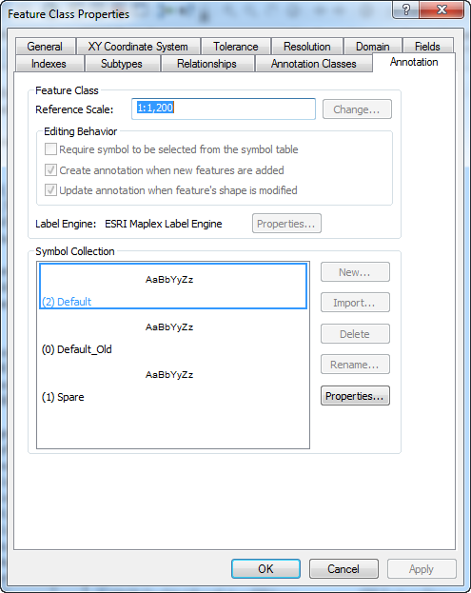

ConduitSystemAnno

DeactivatedElecLineSegAnno

NeutralConductorAnno

PriOHConductorAnno

PriUGConductorAnno

SecOHConductorAnno

SecUGConductorAnno

# ~~14395 - Remove the Job Year AU from All Feature Classes It Is Assigned To In The ElectricDataset On Feature Update~~

~~Remove PGE Install Job Year AU from the following feature classes on feature update.~~

~~To do this,~~

1. ~~In ArcCatalog navigate to the feature class, right click, and select ArcFM Properties Manager.~~
2. ~~Select the Object Info tab.~~
3. ~~Select the dropdown next to On Feature Update and select Multiple.~~
4. ~~Double click the ‘PGE Install Job Year’ AU on the right hand side to remove it and click OK.~~

|  |
| --- |
| ~~EDGIS.AnchorGuy~~ |
| ~~EDGIS.CapacitorBank~~ |
| ~~EDGIS.CircuitRelay~~ |
| ~~EDGIS.ConduitSystem~~ |
| ~~EDGIS.Controller~~ |
| ~~EDGIS.DCConductor~~ |
| ~~EDGIS.DCRectifier~~ |
| ~~EDGIS.DeliveryPoint~~ |
| ~~EDGIS.DeviceGroup~~ |
| ~~EDGIS.DistBusBar~~ |
| ~~EDGIS.DynamicProtectiveDevice~~ |
| ~~EDGIS.FaultIndicator~~ |
| ~~EDGIS.Fuse~~ |
| ~~EDGIS.GenerationRelay~~ |
| ~~EDGIS.Generator~~ |
| ~~EDGIS.GroundingBank~~ |
| ~~EDGIS.Inverter~~ |
| ~~EDGIS.LoadCheckPoint~~ |
| ~~EDGIS.NetworkProtector~~ |
| ~~EDGIS.NeutralConductor~~ |
| ~~EDGIS.OpenPoint~~ |
| ~~EDGIS.PadmountStructure~~ |
| ~~EDGIS.PhotoVoltaicCell~~ |
| ~~EDGIS.PrimaryGeneration~~ |
| ~~EDGIS.PrimaryMeter~~ |
| ~~EDGIS.PriOHConductor~~ |
| ~~EDGIS.PriUGConductor~~ |
| ~~EDGIS.ProtectiveDevice~~ |
| ~~EDGIS.SCADA~~ |
| ~~EDGIS.SecOHConductor~~ |
| ~~EDGIS.SecondaryGeneration~~ |
| ~~EDGIS.SecondaryLoadPoint~~ |
| ~~EDGIS.SecUGConductor~~ |
| ~~EDGIS.ServiceLocation~~ |
| ~~EDGIS.SmartMeterNetworkDevice~~ |
| ~~EDGIS.SpanGuy~~ |
| ~~EDGIS.StepDown~~ |
| ~~EDGIS.StepDownUnit~~ |
| ~~EDGIS.StreetLight~~ |
| ~~EDGIS.SUBBusBar~~ |
| ~~EDGIS.SUBCapacitorBank~~ |
| ~~EDGIS.SUBCurrentTransformer~~ |
| ~~EDGIS.SUBFuse~~ |
| ~~EDGIS.SUBInterruptingDevice~~ |
| ~~EDGIS.SUBOHConductor~~ |
| ~~EDGIS.SUBPotentialTransformer~~ |
| ~~EDGIS.SUBReactor~~ |
| ~~EDGIS.Substation~~ |
| ~~EDGIS.SubsurfaceStructure~~ |
| ~~EDGIS.SUBSwitch~~ |
| ~~EDGIS.SUBTransformerBank~~ |
| ~~EDGIS.SUBUGConductor~~ |
| ~~EDGIS.SUBVoltageRegulator~~ |
| ~~EDGIS.SupportStructure~~ |
| ~~EDGIS.Switch~~ |
| ~~EDGIS.Tie~~ |
| ~~EDGIS.Transformer~~ |
| ~~EDGIS.TransformerDevice~~ |
| ~~EDGIS.TransformerUnit~~ |
| ~~EDGIS.VaultPoly~~ |
| ~~EDGIS.VoltageRegulator~~ |
| ~~EDGIS.VoltageRegulatorUnit~~ |

# 14375 - Remove 'Admin (NO QA/QC) Post Session' from Process Framework (plus 'Test' tasks mentioned in details)

Perform the following steps to remove each of the following tasks:

* Admin NO QA/QC Post Session
* Test GDBM Post Session
* Test DeviceGroup Post Session
* Test QA Post Session

1. Login to the  Process Framework Administration Tool as PROCESS
2. Click on the Node Types tab
3. In the tasks list click on the item entitled: 'Admin (NO QA/QC) Post Session'
4. Click the ‘Delete Task’ button
5. Close the Process Framework Administration Tool and confirm at the prompt asking if you want to save your changes.

# 14389 - EDER Snapping and Stored display

Note: Enable Maplex extension in ArcMap

**INC000003865004 - Clustered Street Names**

**Task 1 - ED Mapping**

* Connect to the target database
* Open ArcMap. When prompted for ArcFM credentials, login to the database as EDGIS.
* Open ED Mapping
* Open Layer Properties for **TomTom Labels** in **Common Landbase – Vector** Group Layer in ED Mapping Stored Display
* Go to Labels Tab
* Click on Placement Properties

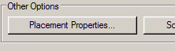

* Go to **Conflict Resolution** Tab in Placement Properties dialog.
* **Check** the Remove duplicates as show below

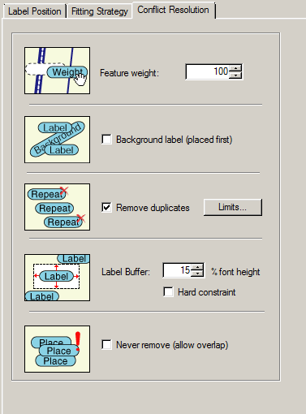

* Click on **Limits** Button 
* Enter **3** in Search radius text box and select **Inches** from dropdown as shown below. Click OK.

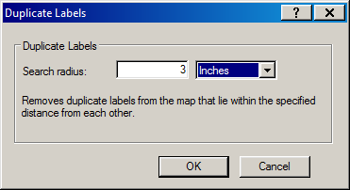

* Click **OK** on Placement Properties dialog and Click **Apply** on Layer Properties Dialog

**Task 2 - ED Mapping**

* Open Layer Properties for **Circuit Point** in **Devices** Group Layer in ED Mapping Stored Display
* Go to Labels Tab
* Click on Placement Properties



* Go to **Label Position** Tab in Placement Properties dialog.
* Click on **Position** Button
* Select the **Centered** option as shown below

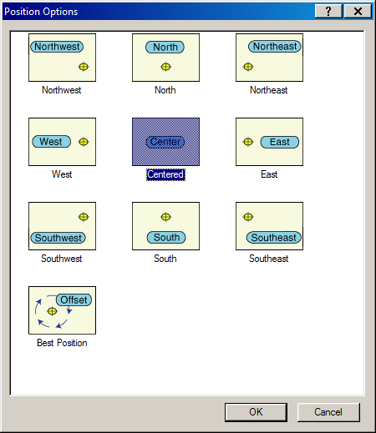

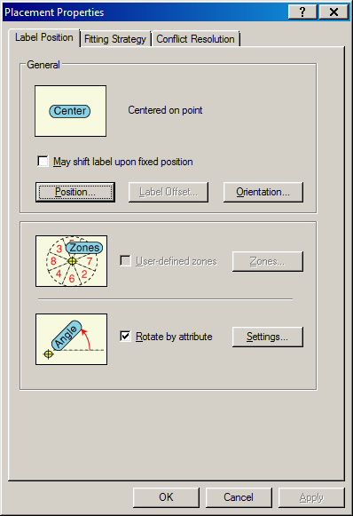

* Click **Ok** on Placement Properties dialog and **Apply** on Layer Properties dialog.

**Task 3 - ED Master and ED Mapping**

* Go to the Table Of Content (TOC)
* Click on List By Selection
* Select the **Water way**  under Selectable list
* Click on Selection icon  to unselect the feature. Please refer the below diagram before the change and after.
* Note: Apply the same change to ED Master Stored Display also

Before

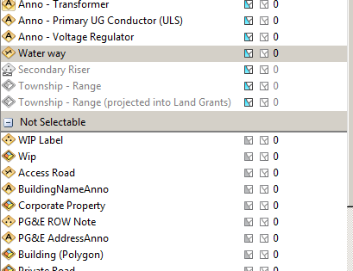

After

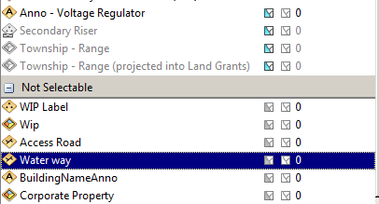

**Task 4 – ED Master and ED Mapping**

* Click **Save As…**from Stored Items in ArcFM toolbar

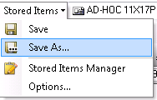

* Select **Stored Display** from Item type dropdown and give the same stored display name and Click **OK**

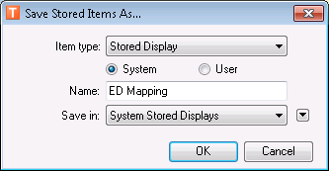

* Click Yes to save the stored display

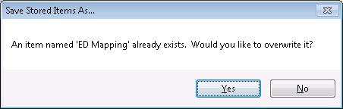

**Snapping Rules**

**Task 1**

* Open ArcCatalog and connect to database with EDGIS user
* Open ArcFM Snapping Manager for the **EDGIS.FaultIndicator available in** ElectricDataset

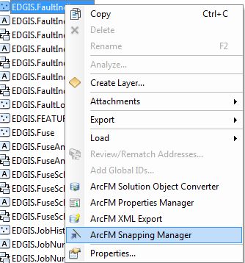

* Change the snapping target as shown in below diagram

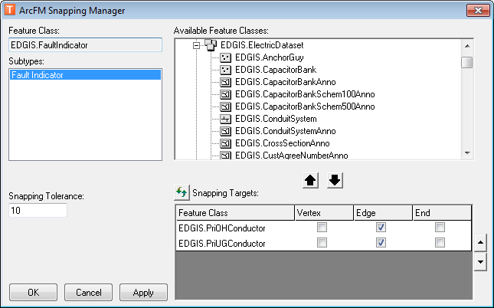

* Click Apply

**Task 2**

* Open ArcFM Snapping Manager for the **EDGIS.PriUGConductor** available inElectricDataset
* Select **Single Phase Primary Underground** from Subtypes list box
* Enter Value **15** in Snapping Tolerance text box
* Click on Apply button. Screen should looks like below

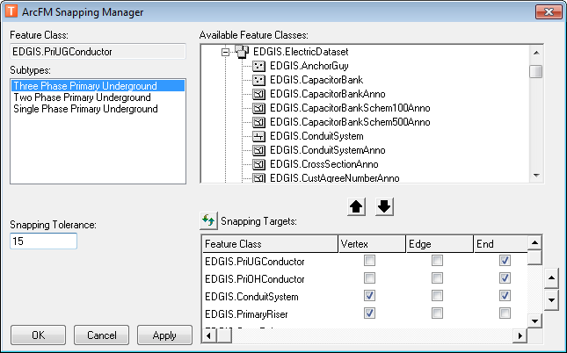

# Import ArcFM Properties XML

1. Refer to Section 1.3 for supporting documents. Copy the XML file locally.
2. Log into the database as EDGIS with a non-default version:  
   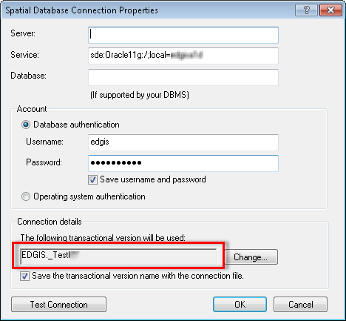
3. The version can be any version owned by EDGIS. If no such version exists, create the version:
   1. Log into the database as EDGIS and right click the SDE connection->Versions…
   2. Scroll to the bottom of the list and right click SDE.DEFAULT->New.
   3. Type in a name, e.g. “TestVersion”, and select OK.
4. Right click the database and select ArcFM XML Import.
5. Select the ‘Overwrite’ option and select the XML that you copied locally.
6. Select ‘Import’.
7. Save the error log to the Release folder as ‘arcfmproperties_import_dm772.log’

# Update Data Model Version Table

**Database Configuration:**

1. Open SQL Plus.
2. Log in using the same server and user as was used in section 2.  
     
   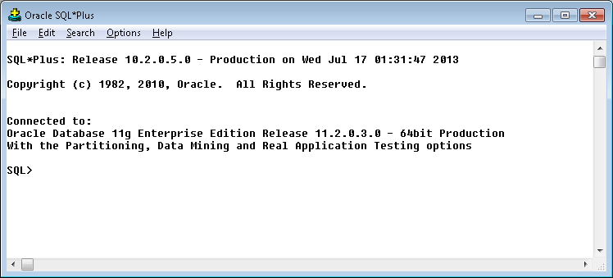
3. Run the SQL below:

update pgedatamodelversion set currentidc='N' where currentidc='Y';

insert into pgedatamodelversion (OBJECTID, CURRENTIDC, DATEAPPLIED, APPLIEDBYPERSONNAME, MODELVERSION) values (**INSERT NEXT VALID ID**,'Y',sysdate,'**<INSERT TEAM MEMBER DONE BY>**','**7.7.2** GOLD **CR14182**');

commit;

# Known Issues

<Please List any other issues encountered here while following the document>